International Journal of English Language Inquiry
Dr. Don Anton R. Balida
State College University, Town/City, Country
Email: author@universitycollege.edu.xx
ORCID: 0000-0003-XXXX-XXXX
Abstract
This sample manuscript demonstrates the required format and structure for papers submitted to the International Journal of Educational Contemporary Explorations (IJECE). It reflects the official author guidelines concerning layout, headings, font, and spacing. The abstract should not exceed 250 words and must summarize the study’s purpose, methods, results, and conclusions. It should be written as a single paragraph without citations. The abstract must be fully justified, written in Calibri 10, and single-spaced.
Keywords: Education; Contemporary Issues; Manuscript Preparation; IJECE; Author Guidelines
1. Introduction
This section introduces the background and rationale of the study. It sets the context by describing the current state of educational research and identifies the research problem the study aims to address. Authors should clearly state the purpose, objectives, and significance of their work. The introduction must be well-organized, concise, and based on recent literature.
All text should use Calibri 10, single-spaced, and justified, without indentation. Authors should ensure that statements of fact are supported by recent and verifiable references (Thompson, 2023).
2. Literature Review
The literature review provides an overview of relevant scholarly works, focusing on studies published within the last five years, except for established theories. It should identify key debates, conceptual frameworks, and gaps the present study intends to fill.
Authors should cite real and verifiable sources in APA 7th edition format. For example:
Recent research on inclusive education emphasizes collaborative frameworks for student success (Garcia & Ahmed, 2022).
3. Methodology
This section outlines the research design, participants or respondents, instruments, data collection, and analysis procedures. For quantitative studies, authors must specify the statistical tools and level of significance (0.05). For qualitative studies, indicate the approach (phenomenology, case study) and describe thematic analysis procedures.
All tables and figures should appear within the text, not in appendices.
Table 1
Sample Format of a Table Title (Above the Table)
Variable | Mean | Interpretation
Teaching performance | 3.45 | High
Student engagement | 3.62 | Very High
As shown in Table 1, results should be clearly presented with proper labeling, complete borders, and referenced within the text.
4. Results and Discussion
Present findings using tables or figures when necessary. Figures must have titles below them, and all explanations should follow directly afterward.
(Insert schematic diagram or conceptual framework here.)
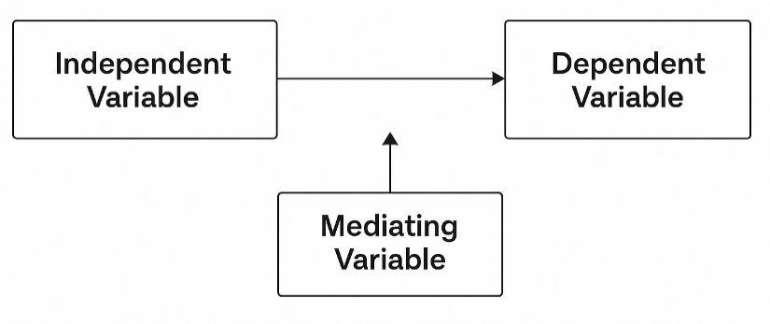
Figure 1
Sample Figure Showing the Conceptual Framework of the Study
As shown in Figure 1, variables should be clearly defined with arrows and boxes connecting them to illustrate relationships.
The discussion should interpret these results in relation to prior literature, highlighting similarities, contradictions, and implications. Each paragraph must flow logically and remain focused on the research objectives.
Implications of the Results/Findings
5. Conclusion and Recommendations
Summarize the main results or findings and relate them to the study’s objectives. Conclusions must be evidence-based and concise. Recommendations should specify practical applications, policy suggestions, or directions for further research.
For example:
The findings underscore the importance of aligning instructional methods with student-centered approaches to foster engagement and learning efficiency.
6. References
All citations must follow APA 7th edition and include real, verifiable sources. At least 10 references are required, with 90% from the last five years. Include DOIs whenever available.
Garcia, M. L., & Ahmed, R. (2022). Inclusive education strategies for developing economies. International Journal of Education and Development Studies, 18(3), 45–60. https://doi.org/10.1234/ijds.2022.067
Smith, J. A. (2023). Digital pedagogy and learner engagement in the post-pandemic era. Educational Research Review, 47(2), 112–130. https://doi.org/10.5678/err.2023.459

